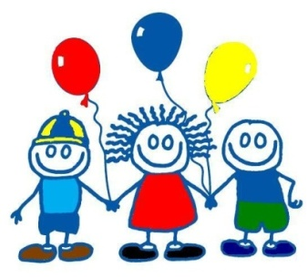
The Preschool is an outreach ministry of St. Paul Methodist Church and is part of its total Christian education program. At St. Paul Preschool our purpose is to provide a loving and positive learning environment to facilitate each child’s emotional, intellectual, physical, social, and spiritual development. Our program is well-rounded, offering a variety of learning experiences to build confidence and self-esteem. We accomplish these goals by:
- Providing an environment for self-expression.
- Developing positive self-concepts.
- Creating respect for self and others.
- Aiding each child in natural curiosity about self, home, community, and God.
- Encouraging healthy peer relationships at work and play.
- Teaching each child to care for personal needs.
- Encouraging independent thinking and problem solving skills.
- Promoting creativity in art, music, and movement.
- Teaching kindergarten readiness skills (in accordance with the state preschool & kindergarten frameworks).
- Offering music and Spanish classes.
- Fostering the child’s heart by providing ongoing opportunities for scripture memory.
The following documents are required for registration at St. Paul Preschool:
- Registration packets (including authorization form)
- Registration fee ($125)
- Copy of birth certificate
- Official immunization compliance form MS 121
HOURS OF PRESCHOOL 8:30 – 11:30

REGISTRATION FORMS ARE AVAILABLE IN THE PRESCHOOL OFFICE.

MUSIC GOALS AND OBJECTIVES
Music and young children are almost synonymous terms. They both invoke a sense of wonderment, enjoyment, laughter, movement, freedom, creativity and expression. Our music activities are designed to:
Teach pride in our heritage by using songs, dances, various instruments and recording.
Help each child learn to identify and differentiate various sounds.
Help each child learn to match pitches, raise and lower their voices.
Help develop an understanding about music, slow/fast, high/low and loud/soft.
Help develop a sense of rhythm and recognize different rhythmic patterns.
Help each child express his/her feelings through creative movement.
Develop gross motor and fine motor skills.
Locate the source of sound with and without visual clues.
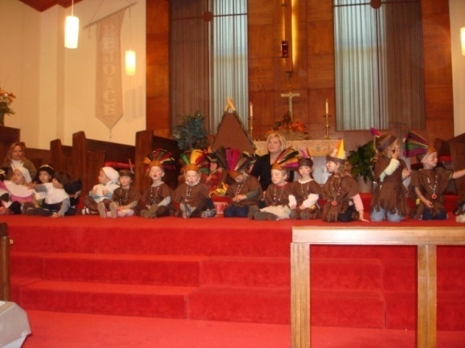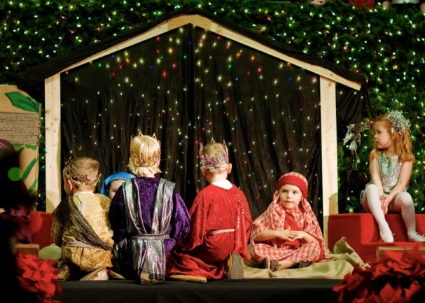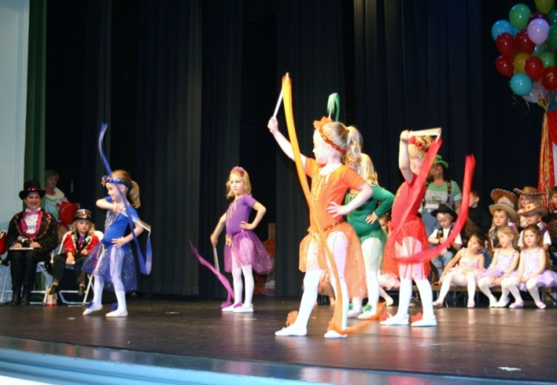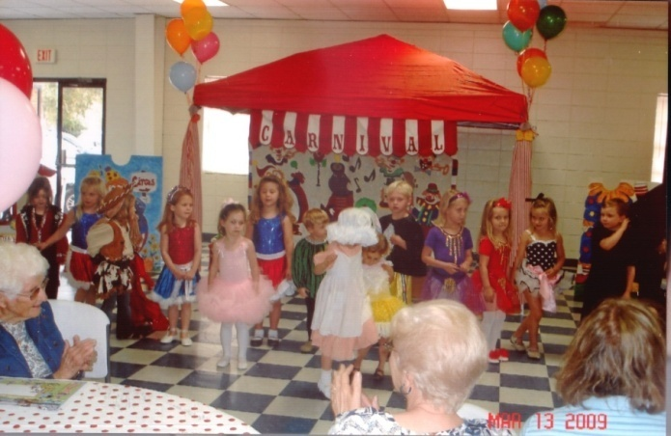
The Thanksgiving and Christmas Programs and the Annual Circus Performances
are still a tradition after over 40 Years.

SPANISH GOALS AND OBJECTIVES
Research has proved that exposing children during their early years to various languages may help increase cognitive abilities, develop a richer vocabulary and improve English and math achievement. Our Spanish program activities are designed to:
Develop awareness that not all people speak the same language.
Help each child learn common greetings in Spanish.
Help each child learn parts of the face, colors, shapes, common foods, numbers and common animals.
Help each child count from 1 to 10 in Spanish.
Expose each child to elements to Spanish cultures through song, dance and celebration.

GOALS AND OBJECTIVES FOR TWO YEAR OLDS
In addition to emphasizing positive self-esteem and beginning to develop a sense of independence, the following goals and objectives are incorporated into the program at St. Paul for children in the two year old program.
SOCIAL DEVELOPMENT
1. Learn the first name of classmates.
2. Learn to adjust to separation from parent.
3. Begin to learn to share toys.
4. Learn to play with other children.
5. Learn to listen when someone else is speaking.
6. Begin to help teacher pick up after work and play.
7. Concept that God made each one special.
8. God made animals and the entire world around us.
MOTOR DEVELOPMENT
1. Roll ball to classmate.
2. Begin to catch ball when rolled to him/her.
3. Learn to play within a boundary.
4. Begin to learn to use crayons and paintbrush.
5. Begin to take care of some personal needs.
6. Begin to learn to pass out cups, napkins and snacks.
7. Learn to follow simple patterns using blocks.
8. Development of eye-hand coordination through the use of manipulative.
9. Use hand puppets and finger plays to develop small muscles.

LANGUAGE DEVELOPMENT
1. Begin to learn rhyming words through the use of nursery rhymes.
2. Introduce numbers 1 through 5.
3. Introduce names of shapes.
4. Introduce names of colors.
5. Learn names of some fruits and vegetables.
6. Learn names of some tame and wild animals.
7. Increase attention span by listening to short story.
8. Begin to follow a simple direction when given verbally.
9. Learn to sing simple songs.

GOALS AND OBJECTIVES FOR THREE YEAR OLDS
In addition to emphasizing positive self-esteem and beginning to develop a sense of independence, the following goals and objectives are incorporated into the program at St. Paul for children in the three year old program.
SOCIAL DEVELOPMENT
1. Learn first names of classmates.
2. Learn to adjust to new situations.
3. Learn to share classroom toys.
4. Learn to share own toys.
5. Learn to play with other children.
6. Begin to learn to share attention.
7. Begin to accept authority from an adult other than own parents.
8. Listen when someone else is speaking.
9. Concept that God made each one special, God made animals and the entire world around us.

MOTOR DEVELOPMENT
1. Roll ball to classmates.
2. Catch ball rolled to him/her.
3. Balance in swing and swing alone.
4. Learn to play within boundaries.
5. Learn to put on and remove sweater or coat by self.
6. Begin to learn to use scissors and crayons.
7. Begin to take care of some personal needs.
8. Learn to pass cups, napkins and snacks.
9. Learn to follow simple patterns using beads and blocks.
10. Development of eye-hand coordination with puzzles and flannel board.
11. Use finger-plays to develop small muscles.

LANGUAGE DEVELOPMENT
1. Learn rhyming words through use of nursery rhymes.
2. Introduce numbers 1- 10.
3. Introduce names of shapes.
4. Introduce names of colors.
5. Introduce opposite concepts.
6. Learn to recognize first name.
7. Learn names of fruits and vegetables.
8. Learn names of tame and wild animals.
9. Learn to speak so someone else can easily understand.
10. Increase attention span by listening to short story.
11. Follow a simple direction when given verbally.
12. Learn to help teacher pick up after work and play.
13. Learn simple songs in music.
14. Learn to speak in front of class during show and tell.
15. Learn Pledge of Allegiance to Flag.
16. Learn proper use of telephone.
17. Learn parent’s names.

GOALS AND OBJECTIVES FOR FOUR YEAR OLDS
In addition to emphasizing positive self-esteem and to develop a sense of independence, the following goals and objectives are incorporated into the program at St. Paul for children in the four year old class.
1. Concept of left to right progression.
2. Learn to work from top to bottom of paper.
3. Recognize own name when written in upper and lower case letters.
4. Recognize numbers 1-10 when written, and progress forward, if possible.
5. Know the eight basic colors.
6. Follow simple directions.
7. Learn comparative words such as large vs. small, etc.
8. Listening skills:
a. Follow verbal directions.
b. Listen at story time.
c. Simple discrimination between sounds.
9. Recognize basic shapes (circles, squares, triangles, etc.).
10. Develop small motor skills through cutting and pasting as well as finger-plays.
11. Learn terms for sequencing such as first, second, third, etc.
12. Respect for property of others.
13. Progress from front to back of story book.
14. Learn to take turns and share.
15. Establishment of patriotism through Pledge to Flag, respect of flag and patriotic songs.
16. Introduction of all letters of the alphabet (upper and lower cases), initial consonant sounds.
17. Take care of personal needs such as putting on coat, buttoning buttons, zipping zippers,
snapping snaps, etc. (Please dress your child in clothes that he/she can manage. No belts
that are hard to buckle, no buttons on the shoulders of clothes, no jeans that are difficult to
snap, etc.).
18. Development of gross motor system through dancing, exercises, games, etc.
19. Learn to speak in front of group through show and tell.
20. Learn to pick up toys and put them in proper places.
21. Speak in complete sentences.
22. Safety on playground.
23. Development of self-satisfaction and feeling of being someone special.
24. Learn to write name with pencil in upper and lower case letters.
25. Concept that God made each one special, God made animals and the entire world around us.

