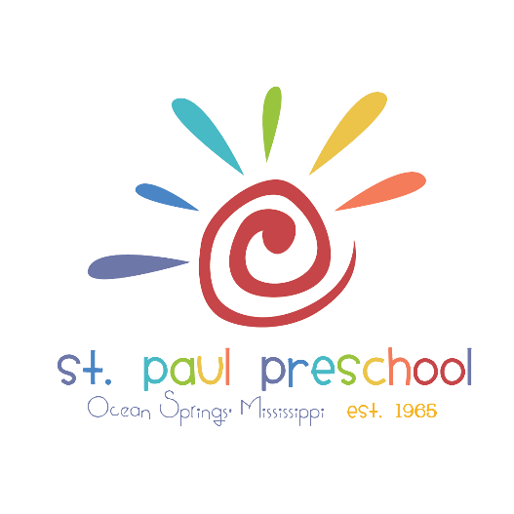

INFORMATION ON 2024-2025 SCHOOL YEAR
Please retain this sheet for future reference
At St. Paul Preschool our purpose is to provide a loving and positive learning environment to facilitate each child’s emotional, intellectual, physical, social, and spiritual development. Our program is well-rounded, offering a variety of learning experiences to build confidence and self-esteem. We accomplish these goals by:
- Providing an environment for self-expression.
- Developing positive self-concepts.
- Creating respect for self and others.
- Aiding each child in natural curiosity about self, home, community, and God.
- Encouraging healthy peer relationships at work and play.
- Teaching each child to care for personal needs.
- Encouraging independent thinking and problem solving skills.
- Promoting creativity in art, music, and movement.
- Teaching kindergarten readiness skills (in accordance with the state preschool & kindergarten frameworks).
- Offering music and Spanish classes.
- Fostering the child’s heart by providing ongoing opportunities for scripture memory.
The Preschool is an outreach ministry of St. Paul Church and is part of its total Christian education program.

